IT24100033

IT2120 - Probability and Statistics

Lab Sheet 4

**Exercise**

1.

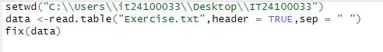

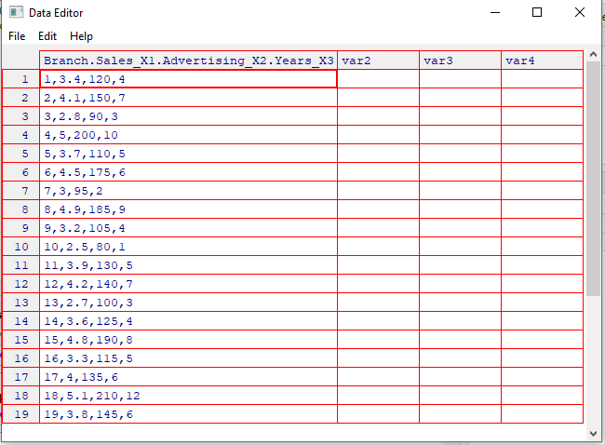

2.



3.

4.

5.

